Hill Stations:

Swat

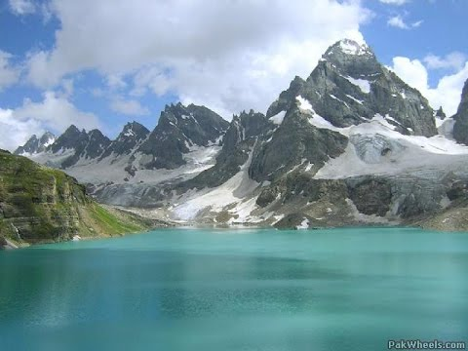

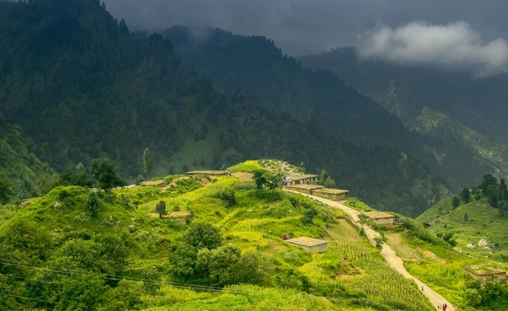

**Swat District** is a district in Malakand Division of Khyber Pakhtunkhwa province in Pakistan. Swat is renowned for its outstanding natural beauty.Centred upon the upper portions of the Swat River, Swat was a major centre of early Buddhist thought as part of the Gandhara kingdom, and today is littered with ruins from that era. Swat was home to the last isolated pockets of Gandharan Buddhism, which lasted until the 11th century, well after most of the area had converted to Islam. Until 1969, Swat was part of the Yusafzai State of Swat, a self-governing princely state. The region was seized by the Pakistani Taliban in late 2007, and its tourist industry decimated until Pakistani control over Swat was re-established in mid 2009.